Editing Guidelines for Acta Electrotehnica Articles

Dan Iudean1, Călin Mureşan1, Valentin D. Zaharia1

1Faculty of Electric Engineering, Technical University of Cluj-Napoca, Romania

**Abstract** - This document represents a mandatory guideline for editing articles for Acta Electrotehnica. The articles must be submitted in “.docx” format only and must comply with all the editing rules described below. Should these requirements not be fulfilled, the editing team will kindly ask the authors to revise the formatting according to the guidelines and to resubmit the article in the appropriate format.

**Keywords –** at least five representative terms within the paper’s body

1. Introduction[1]

The paper layout settings must be the following:

* + paper size: A4 (210x297 mm), portrait
  + margins: Top=2.54 cm, Bottom=2.54 cm, Inside=1.59 cm, Outside=1.59 cm, Gutter=1cm, Header=1.27cm, Footer =1.27cm, Mirror margins
  + section start – continuous
  + Vertical alignment – top
  + Different odd and even pages
  + bullets must have the same indent as the first line of the paragraph (left= .75 cm) and the “special” setting “Hanging of 0.65cm”
  1. Paper information

The paper’s title must be written in “Times New Roman” font, with a font size of 24, Bold, Italic, Center, Left and Right Indentation of 0.95, Spacing before=60pt and 0 after, with single line spacing. The words in the title must start with a capital letter, excepting the connecting words (e.g. *of, the, a, for, and* etc.).

The authors’ names must contain the full first name and the full last (Family) name, with the first capital letter. The font must be Times New Roman, font size 14, Centered, indentation left=0.95cm and right =0.95 cm, spacing before=12, after = 6 and a single line spacing.

The authors’ affiliations must be marked by superscript numbers placed after each author’s last name and must be written underneath the authors’ names section, in Times New Roman font, size 8, centered, with a left and right indentation of 0.95 cm and single line spacing and 0 cm spacing before and after.

The corresponding author is also presented at the end of the article, with the full name, address, city, country and email address.

The article’s abstract must be written in Times New Roman, size 9, Italic, Justified, 0 cm indentation, Spacing before=12 and spacing after=6.

The keywords section must be contain at least five representative terms within the paper’s body and must be written in Times New Roman, size 9, Italic, Justified, 0 cm indentation, Spacing before=12 and spacing after=6.

1. Section titles

The section titles must numbered with Arabic numerals (1,2,3...) and must be written in Times New Roman, size 10, Bold, Caps Lock, alignment Left, Left and Right Indentation 0 cm, Hanging 0.75 cm, Spacing Before = 12 and After = 9, single spacing.

* 1. Sub section title (first level)

The first level subtitle must be numbered with Arabic numerals consisting of two numbers separated by a dot. The first number represents the current section and the second number represents the subsection and must be written in Times New Roman, size 10, Bold, Normal text, alignment Left, Left Indentation= 0.5 and Right Indentation 0 cm, Hanging 0.75 cm, Spacing Before = 12 and After = 9, single spacing.

* + 1. Second level sub section

The second level subtitle must be numbered with Arabic numerals consisting of three numbers separated by dots. The first number represents the current section and the second number represents the current subsection and the third number represents the sub-subsection. It must be written in Times New Roman, size 10, Normal text, alignment Left, Left Indentation= 0.5 and Right Indentation 0 cm, Hanging 0.95 cm, Spacing Before = 12 and After = 9, single spacing.

1. Text properties

The article’s body must be written in two columns text, of equal width, with a spacing of 0.95 cm. The text must be Times New Roman, size 10, justified, with a first line indentation of 0.75 cm and single line spacing.

Figures must be inserted only with the “Insert picture” option, in line with the text. The figure caption must be placed under the image and must must contain the figure number and the image description, written in Times New Roman, size 8, centered, without indentation. Spacing Before = 8 and After = 8, The image caption muse have the following format:

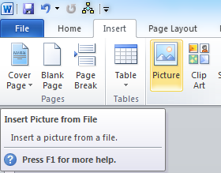

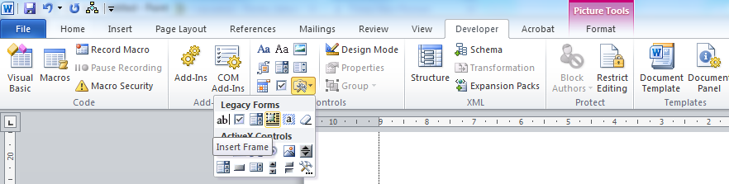

Fig. 2 Insert frame

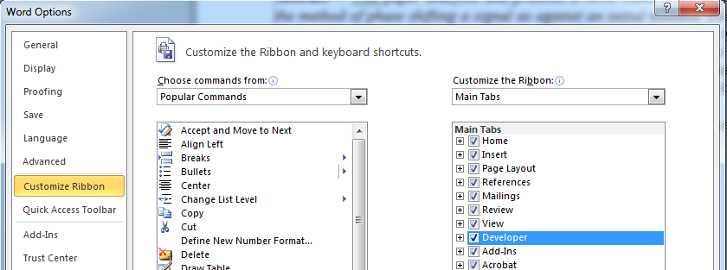

Fig. 3 Activate developer tab

Fig. 1 – Image description .

Figures which exceed in size the width of a column can be placed on the whole width of the page only by using frames (figure 2) with the following configuration: no borders, no margins, text wrap – none, don’t move with text, position centered relative to margins (figure 4). The frame can be inserted using the developer tab witch can be activated in Option -> Customize Ribbon (figure 3).

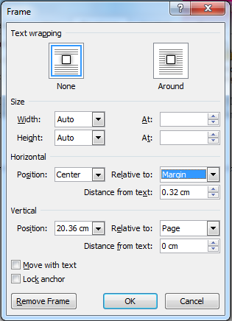

Fig.4 Frame properties

The table caption must be inserted before the actual table and must contain the table number and description, written in Times New Roman, size 8, centered, without indentation. The image caption must have the following format:

Table 1 – Table description

|  |  |
| --- | --- |
|  |  |
|  |  |

Equations must be inserted only with Microsoft Equation 3.0 (Insert->Object->Microsoft Equation 3.0, figure 5). Equations must be aligned to the left and their respective numbers must be aligned to the right, according to the following example:

|  |  |
| --- | --- |
|  | (1) |

The equation above is inserted within a two-column table with invisible borders. For ease of formatting purposes, please use the same method for inserting the equations in the paper.

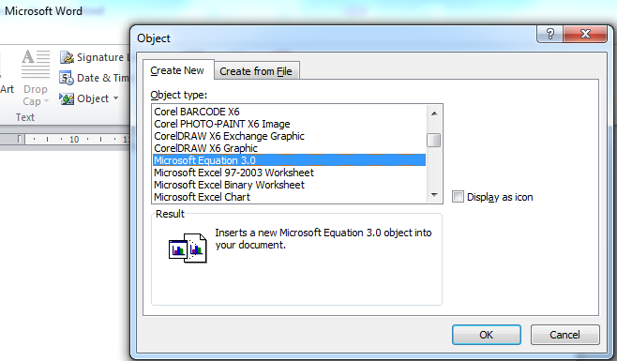

Fig. 5 Insert equation

The references must be ordered alphabetically after the first author’s last (family) name and must be numbered. The reference tag must be placed in the paper’s body and it must contain the number in the reference list, in square brackets.

References

1. IudeanD., MureşanC, Zaharia V.D., “Editing guidelines for Acta Electrotehnica articles”, Acta Electrotehnica, vol. 55, nr. 1-2, Mediamira Science Publisher, 2014

Dan Iudean

Faculty of Electrical Engineering, Technical University of Cluj-Napoca, 26-28, G. Bariţiu st., Cluj-Napoca, Romania

Dan.Iudean@ethm.utcluj.ro

1.